TRAVEL ITINERARY PLANNER
@CREATIVITY THINK (9483175986/7019689991)

ABSTRACT:
Travel Itinerary Planner is a web application designed to assist vacationers and event planners in organizing and managing detailed travel plans. Users can create trips, add location stops and notes, sync itineraries with calendars, and view progress through dashboard charts. Administrators manage travel templates, moderate user itineraries, and analyze dashboard metrics. The backend leverages Django and Django Rest Framework for secure data handling, authentication, and business logic, while the frontend uses React, Recharts, and Axios for a responsive, interactive interface. This platform simplifies travel planning and provides actionable analytics for users and administrators..

INTRODUCTION OF THE PROJECT:
Planning a trip requires careful organization of destinations, dates, and activities. Travel Itinerary Planner offers a web platform where users can create detailed itineraries, add stops, write notes, synchronize with calendars, and track plans using dashboards. Administrators manage pre-defined templates and tours, moderate user submissions, and analyze travel patterns. Using Django and Django Rest Framework for the backend and React with Recharts on the frontend ensures secure, responsive, and user-friendly trip planning and administrative oversight..

PROJECT OBJECTIVES:

• Provide users with tools to plan trips and itineraries
• Allow addition of stops, notes, and schedules
• Sync travel plans with personal or shared calendars
• Enable exporting and sharing of itineraries
• Allow administrators to manage templates and tours
• Moderate user trips for quality and compliance
• Provide dashboards and analytics for planning insights

PROBLEM OF THE STATEMENT:
Organizing trips and travel schedules can be complex, leading to missed activities or inefficient planning. Users often struggle to maintain structured itineraries and synchronize with calendars. Administrators face challenges in managing multiple trip templates, moderating user-generated itineraries, and analyzing trends. Travel Itinerary Planner addresses these issues by providing an intuitive platform for detailed trip planning, calendar integration, and analytics-driven insights for both users and administrators, ensuring well-organized and efficient travel experiences..

MOTIVATION OF THE PROJECT:
• Simplify travel planning for individuals and groups
• Provide structured itineraries and location tracking
• Integrate with personal and shared calendars
• Enable administrators to manage templates and analyze trends
• Ensure smooth, organized, and efficient travel experiences

BLOCK DAIGRAM OF PROJECT:

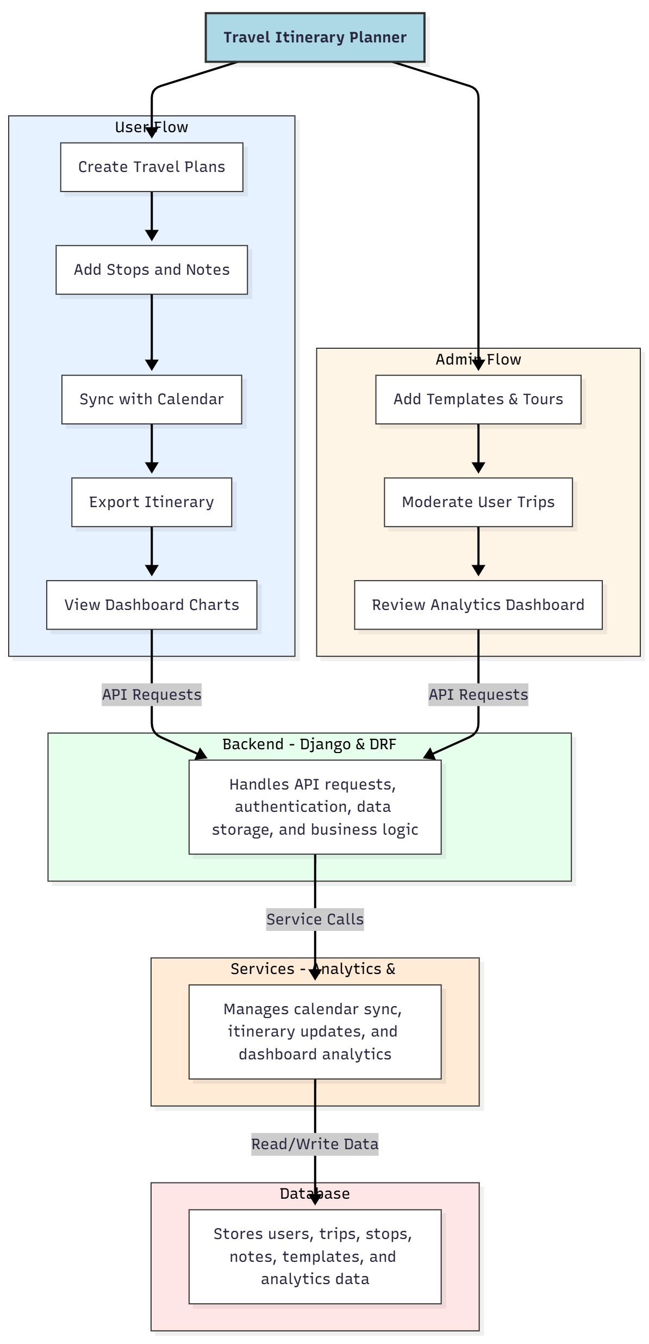

WORKING OF THE PROJECT:
Users create travel plans by adding stops, notes, and scheduling dates. They can sync their itineraries with personal calendars, export plans, and visualize trips using dashboard charts. The backend processes API requests, manages authentication, stores trip and template data, and executes business logic. Services handle calendar synchronization, itinerary updates, and analytics. Administrators manage templates and tours, moderate user trips, and review dashboards for insights, ensuring efficient trip planning and quality oversight..

SOFTWARE REQUIREMENT:
- Backend:
  - Python 3.x
  - Django
  - Django REST Framework
  - SQLite/PostgreSQL
- Frontend:
  - Node.js and npm
  - React.js
  - Axios
- Development Tools:
  - Visual Studio Code
  - Postman (for testing APIs)
  - Git/GitHub (for version control)
- Server/Deployment (Optional):
  - Gunicorn, Nginx, or Heroku/AWS for hosting

ADVANTAGES OF THE PROJECT:

• Simplifies travel planning for users
• Structured itinerary creation with multiple stops
• Calendar integration for schedule tracking
• Exportable and shareable travel plans
• Administrative control over templates and tours
• Moderation of user trips
• Analytics dashboards for planning insights
• Web-based and accessible from multiple devices

APPLICATIONS OF THE PROJECT:
• Individual travel planning for vacations
• Event and corporate trip planning
• Educational tour planning
• Tourist itinerary management
• Travel agencies to provide templates
• Monitoring and analyzing travel patterns
• Calendar-synced itinerary reminders
• User-friendly web-based travel dashboards

REFERENCES:

- Django REST Framework Documentation — Django Software Foundation. Django Documentation. Available: https://docs.djangoproject.com/
- Django REST Framework. DRF Documentation. Available: https://www.django-rest-framework.org/
- React. React Official Documentation. Available: https://reactjs.org/docs/getting-started.html
- Redux. Redux Documentation. Available: https://redux.js.org/introduction/getting-started
- PostgreSQL Global Development Group. PostgreSQL Documentation. Available: https://www.postgresql.org/docs/
- MySQL. MySQL Reference Manual. Available: https://dev.mysql.com/doc/
- Git. Git Documentation. Available: https://git-scm.com/doc
- Node.js. Node.js Documentation. Available: https://nodejs.org/en/docs/
- Axios. Axios Documentation. Available: https://axios-http.com/docs/intro
- Socket.io Documentation – https://socket.io/docs/

